LINK AGGREGATION, LACP & PAgP

Table of Contents
1. Configure and verify (Layer2/Layer3) EtherChannel (LACP) 1
Reasons to use EtherChannel 2
Layer 2 EtherChannel 2
Layer 3 EtherChannel 2
Benefits of EtherChannel 3
Requirements to make EtherChannel: 3
Relationship of Physical Ports, Logical Port Channels, and Channel Groups: 4
EtherChannel Load Balancing Algorithm: 4
Types of EtherChannel 4
1. Static EtherChannel 4
Lab on EtherChannel 5
Creating bundle 5
Dynamic EtherChannel 7
2. Dynamic EtherChannle 7
LACP 7
PAGP 7

Configure and verify (Layer2/Layer3) EtherChannel (LACP)
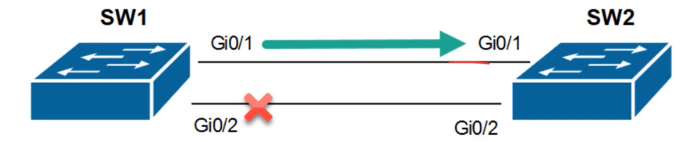
Figure 1: STP without EtherChannel

Why is one link blocked between the switches?
By default, cisco switches have a layer 2 loop prevention protocol known as Spanning-Tree Protocol (STP). Therefore, physically interconnecting switches, as shown in the previous diagram, will cause STP to automatically block one of the interfaces.

Bit of background
This is where EtherChannels come in to save us once more. An EtherChannel allows us to combine multiple physical ports on a switch to create a single logical interface. Therefore, the EtherChannel will carry the total bandwidth of all physical ports combined.

Definition
EtherChannel is a technology that bundles multiple physical Ethernet links into one logical link. It provides increased bandwidth, redundancy, and load balancing.

Reasons to use EtherChannel
Increase bandwidth
Redundancy
Load balancing
STP treats it as one logical link
Faster convergence after a failure

Solution provided by EtherChannel
Single-link bottleneck
Single point of failure
STP blocking redundant links

Layer 2 EtherChannel
There are Layer 2 EtherChannel as well Layer 3 EtherChannel. Layer 2EtherChannel is a logical interface that bundles multiple physical switch ports into a single Layer 2 link. It operates as a switchport, carries Ethernet frames and VLAN traffic, can be configured as either an access port or a trunk port, and does not have an IP address because it performs switching rather than routing.

What must match before an EtherChannel Forms
Speed, Duplex, VLAN

Layer 3 EtherChannel
Layer 3 EtherChannel is a logical inter

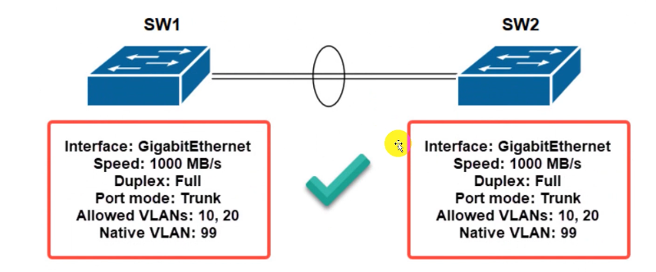
Figure 1: STP with EtherChannel
IT is used to aggregate multiple physical link into a logical link called port channel.

Benefits of EtherChannel
EtherChannel provides the following benefits in an enterprise network:
- Rather than configuring individual interfaces, the configurations can be done directly on the EtherChannel interface, rather than the physical ports.
- Implementing EtherChannels on a network can assit with load balancing and the link aggregation of traffic between switches.
- EtherChannels use the existing physical interfaces on a switch; therefore, we do not need to install additional modules.

Requirements to make EtherChannel:

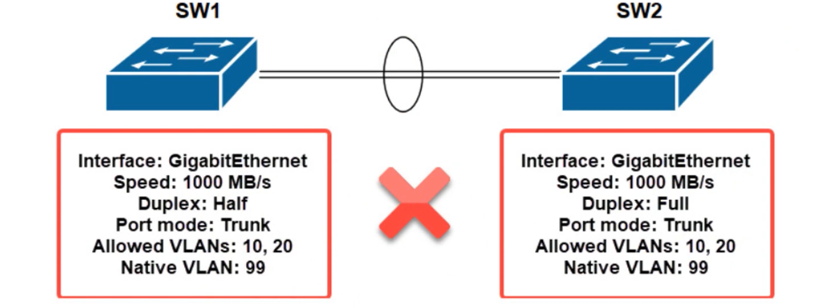

Requirements:

Speed must match.
Duplex must match.
Ethernet IEEE standard must match.
Trunk encapsulation protocol must match
Trunk allowed vlan list must match.
Native vlan must match.
Prunning eligibility list must match (unwanted broadcast on both sides should be blocked).

Relationship of Physical Ports, Logical Port Channels, and Channel Groups:
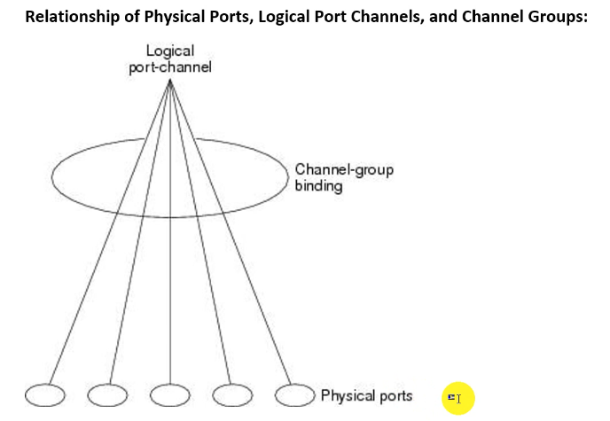

EtherChannel Load Balancing Algorithm:
- Src mac address (bydefault running)
- dst mac address
- src and dst mac address
- src ip add
- ds tip add.
- Src and ds tip add
- Src port number
- Dst port no.
- Src and dst port number

Types of EtherChannel

1. Static EtherChannel

Static EtherChannel:
Sw(config-rang-if)#channel-group 1 mode on

Static etherchannel supports maximum 8 links aggregation.
Mode=ON

NOTE: When we configure an EtherChannel in the ON mode, no negotiations take place. The switch forces all compatible ports to become active in the EtherChannel. The other end of the channel (on the other switch) must also be configured in the on mode; otherwise, packet loss can occur.

Lab on EtherChannel
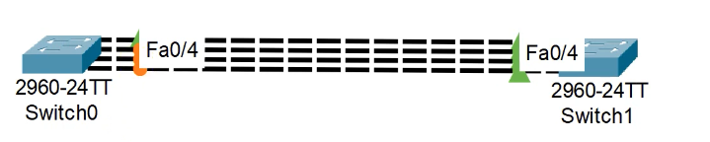
Here, switch 1 is root switch as all the ports are Dp or Fwd port
Fa0/3 Desg FWD 19 128.3 P2p
Fa0/4 Desg FWD 19 128.4 P2p
Fa0/1 Desg FWD 19 128.1 P2p
Fa0/2 Desg FWD 19 128.2 P2p
Switch1#

--------------------------------
Fa0/1 Root FWD 19 128.1 P2p
Fa0/2 Altn BLK 19 128.2 P2p
Fa0/3 Altn BLK 19 128.3 P2p
Fa0/4 Altn BLK 19 128.4 P2p
Switch0

Creating bundle
If we are configuring new device, we will shut them first and we configure them but if we are working on existing/working device, we won’t shut as that is helping in communication.

Int range fa0/1-4
!switchport trunk encap dot1q
Switchport mode trunk
Channel-group 1 mode on
No shutdown
Exit

Int po1
Swi trunk encap dot1q
Sw mo trunk
no sh
this above case usually happens itself. Incase if it doen’t happens then we should run above commands.

Sh interfaces trunk
Sh etherchannel summary
Sh interfaces fa0/1

On another switch
exit
interface range fa0/1-4
swithcport mode trunk
switchport mode trunk
channel-group 1
mode on
channel-group 1 mode on
no shut
exit
do sh hist
Switch0(config)#

Conclusion

We used 4 ports and bundled them.

Dynamic EtherChannel
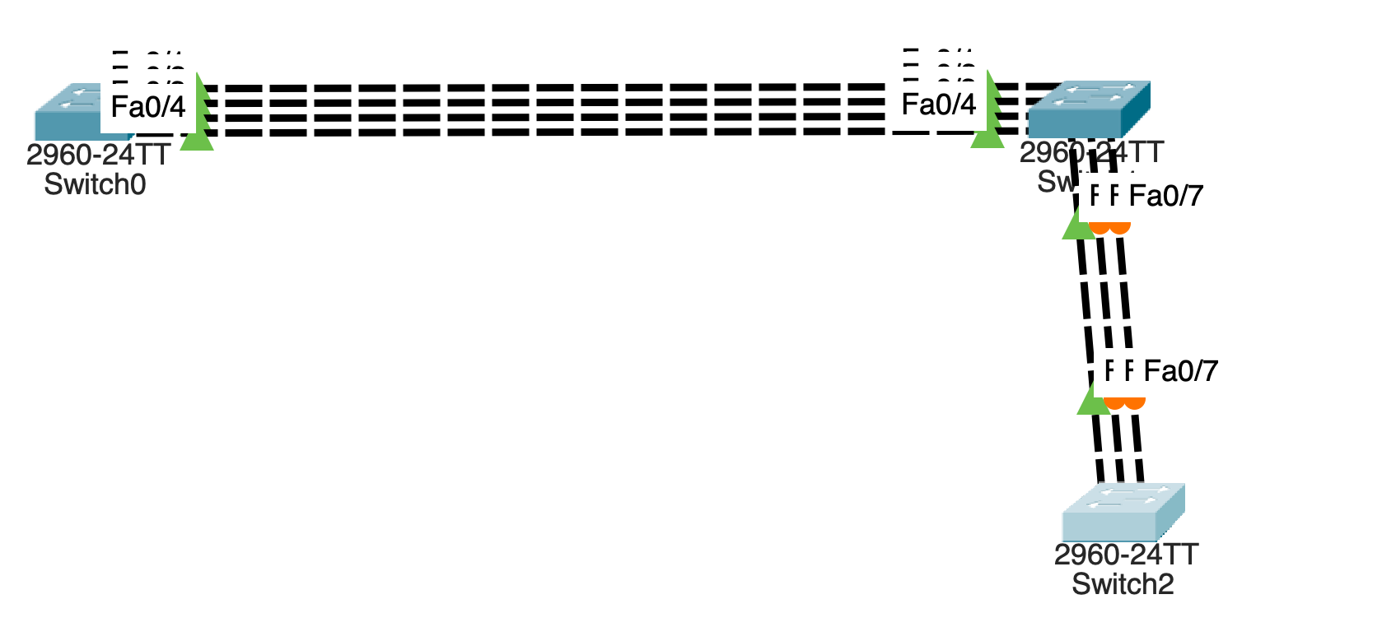

Here, we added another switch with 3 port assigned.
Now we will use static etherchannel on here again as above.

interface range fa0/5-7
swithchport mode trunk
!Switchport trunk encap dot1q
switchport mode trunk
switchport nonegotiate
channel-group 2 mode on
no shut
exit
do sh hist
Switch2(config)#

ON means static etherchannel and it is mode rather than protocol.

2. Dynamic EtherChannle

LACP

PAGP

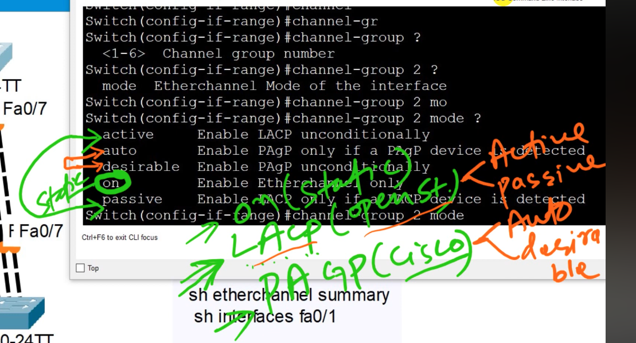

LACP (open standard)
- Active ( both side active is correct)
- Passive ( both side passive is incorrect)

PAgP (cisco)
- Auto (both side auto is wrong)
- Desirable ( both side desirable is correct)

We can’t mix protocol between LACP and PAgP but we can mix between their own working protocol.
Tips: it is always the best to use static etnerchannel in server.

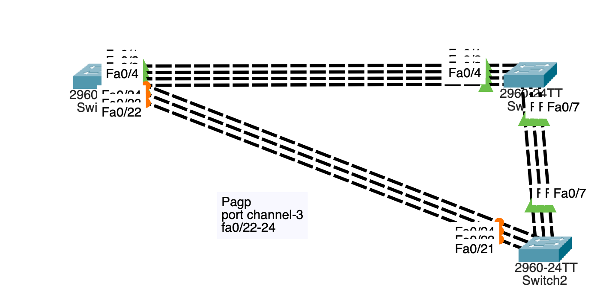

Switch0(config-if-range)#do sh hist
interface fa0/22-24
interface range fa0/22-24
switchport mode trunk
switchport nonegotiate
no shut
channel-protocol pagp
channel-group mode desirable
channel-group 3 mode desirable
no shut
do sh hist

interface range fa0/21, fa0/23-24
switchport mode trunk
switchport nonegotiate
no shutdown
channel-group 3 mode pagp
channel-protocol pagp
channel-group 3 mode auto
no shut
exit
do sh hist
Switch2(config)#

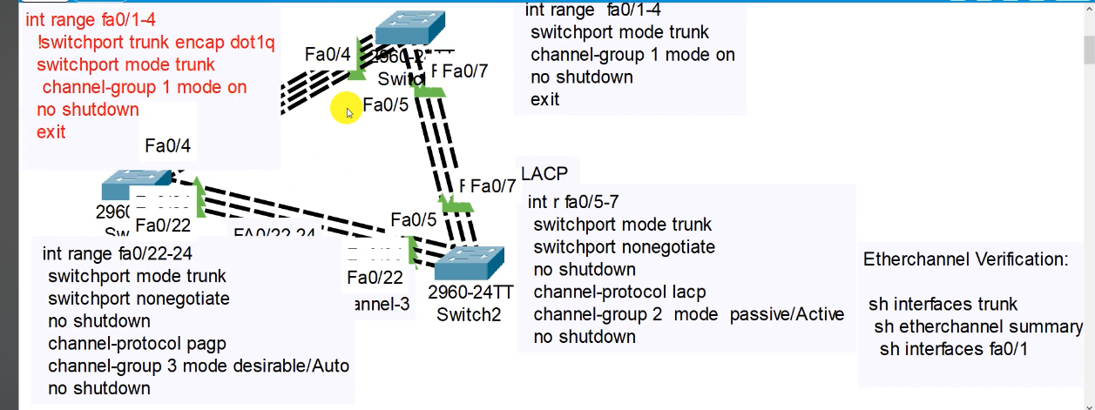

Layer 3 Etherchannel

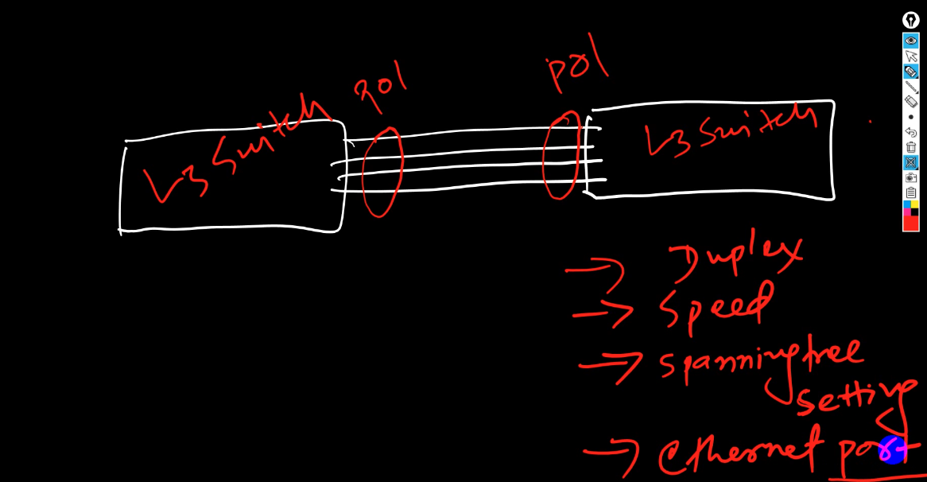
Ethernet port means LAN

